**COMPRESSION SOFTWARES**

DESIGN PROJECT REPORT

Submitted by

**VIVEK SREEDHAR (TKM16CS068)**

**SANOOP S (TKM16CS051)**

**SAMAR MUSTHAFA (TKM16CS049)**

To

*The APJ Abdul Kalam Technological University*

*In partial fulfillment of the requirements for the award of B. Tech Degree*

*In Computer Science and Engineering*

**Department of Computer Science and Engineering**

T. K. M. College of Engineering, Kollam

**TABLE OF CONTENTS**

**Title**

**Chapter 1 – Selection of three Compression Software** 1

* 1. Selecting the apps
     1. PeaZIP/Winzip
     2. Winrar
     3. 7Zip

**Chapter 2 – Design Tool** 11

2.1 Design Tools

2.2 Adobe XD

2.2.1 Adobe XD Features

**Chapter 3 – Features Study and Comparison** 16

3.1 Features identified

3.1.1 Winzip: Features

3.1.2 Winrar: Features

3.1.3 7zip: Features

3.2 Performance case studies

3.3 Features Adapted

**Chapter 4 – User Experience and Analysis** 22

4.1 Methods of UX analysis

4.1.2 User surveys

4.2 Analysis of Survey responses

4.2.1 Impact on Current features

4.2.2 Changes adopted

**Chapter 5 – GUI Design** 30

5.1 User Interface Comparison

5.1.1 Logo

5.1.2 Homescreen UI

5.1.3 Functionality Tuning

5.1.4 UI adaptations

**Chapter 6 – Scalability and Deployability study** 38

6.1 Scalability

6.2 Deployability

6.3 Adaptations

**Chapter 7 – Performance analysis** 41

7.1 Performance Comparison

7.3 Adapted features

**Chapter 8 – Safety and Security** 42

8.1 Safety measures

8.2 Security flaws

**Chapter 9 – Maintenance and handling** 44

**Chapter 10 – Cost and pricing** 45

**Chapter 11 – Development of the design** 46

11.1 Design

11.2 Basic UI design

11.3 Feature manipulation UI

11.4 Functionality Tuning

**Chapter 12 – Conclusions and References** 53

**ABSTRACT**

This project takes a different view at compression software in general as it provides its users a chance at reducing files over a lossy extension or algorithm and still be able to reproduce the original file. It brings with it, several other features like a high system usage-no background running high performance mode, a low system usage silent soft compression and modularity all of which aims at reducing its impact on the host system.

**INTRODUCTION**

LossBACK is a compression software that was developed as per the idea of using lossy compression formats in the place of Lossless extensions. This design report covers the various aspects of software development that we came across when we were developing LossBACK. This included an extensive comparison between the software selected in terms of the certain aspects that would help aid the design process. This included Feature comparison, Interface comparison, Deployability and scalability, Safety and security, etc. This was very necessary as it paved way for proper comparison and adaptation of features that were the most favorable among the competition. This in turn would help create a software that is altogether better than the all original software.

1. **PRODUCT SELECTION**
   1. **SELECTING THE COMPRESSION SOFTWARE**

Data Compression, Source coding or bit-rate reduction in signal processing involves encoding information using fewer bits than the original representation. Data Compression in practise is the process of reducing the size of a data file. In the case of data transmission; the same is called source coding; since encoding is done at source before transmission.

Compression is useful since it reduces the resources required to store and transmit data. Compression and decompression require computational resources. It is subject to a space-time complexity trade off. Compression design schemes involves trade-offs between degree of compression, amount of distortion, involved and the Computational Resource consumption.

Data Compression is of two types:

1. Lossless Compression:

These Algorithms exploit statistical redundancy to represent data without losing information. This process is completely reversible. An example of run-length encoding is; when an image with several repititive pixels, instead of encoding red pixel, red pixel . There are several redundancy elimination schemes.

The Lempel-Ziv(LZ) compression is one of the most popular lossless algorithms. DEFLATE is an adaptation of the LZ focusing on decompression speed and compression ratio with a compression speed trade-off. The Lempel-Ziv-Welch algorithm is also popular for its use in several General-Purpose compression systems. LZ methods are used in table-based compression models where repeated entries occur for reduntant strings.

Strongest modern lossless compressers are probabilistic models like prediction by partial matching, Burrows wheel Transform. The Class of Grammar coded codes are extremely effective in compressing highly reduntant data. Eg: Sequitr, Re-pair. The arithmetic coding is an refinement of probabilistic models is superior to better known algorithms like Huffman encoding. Some lossless compressions are ; Zip, gzip, png, xz, 7z, ALAC, MPEG-4, ALS, FLAC, PGF, BiM, AV1, vfW,etc.

(2)Lossy Compression:

Lossy or reversible compression is a class of data encoding methods that uses inexact approximation and partial data discarding to represent the content. In these schemes, some information loss is acceptable. Dropping non essential details saved storage space. Lossy compression schemes are designed on how people percieve data. JPEG compression works in part by rounding off non-essential data bits. Here; the trade off occurs between percieving information and reducing size.

Digital Cameras and DVDs use lossy image-Video coding formats to increase storage capacity with minimal quality degradation. Whereas audio compression relies on psychoacoustics or removal of inaudible audio components. Some methods are; BPG, DjVu, ICEG(used in mars rovers), JPEG, JPEGxR, JPEG2000, MPEG-1, MPEG-2, MPEG-4, Dirac, Opus, VC-1, AAC, MP3.

These are some format the data is being compressed into Applications softwares use these compression method to achieve data compression and generally incorporates several compression formats among which the user choose a suitable one. Some examples of such popular applications are WinRAR, WinZIP, 7ZIp, KGB Archiever, Uni Extract, Peazip, Zipware, Hamsterzip, etc. Some of these are specific for certain tasks while others are more functional and support more formats. Applications like KGB Archiever is theoritically said to provide a 1000 times compression ratio with lossy compression , provided, the necessary reduntant data is present. This Design Project primarily focuses on three of the above softwares, their codes and formats, features and later on introduce a new compression method and a hypothetic application that implements this feature. The softwares discussed are WinRAR, PeaZIP, 7Zip.

* + 1. **PeaZIP (Later decided upon WinZIP)**

PeaZIP is a free opensource File manager and archiver for Windows, Linux and BSD made by Giorgio Tani. It supports its native PEA archive format while featuring other mainstream formats too. It supports 188 file extensions. It works like IA-32, x64, ARM architectures like RAR and extensions. It is written in Free Pascal and is multilingual features 30 features (17 less than RAR). It has a GNU-Lesser General Public License.

Figure 1.1 Peazip

Features:

* Creation and credit archives, restore to source.
* Archive conversion, file splitting and joining , source file deletion, byte to byte compression, archive encryption, checksums.
* DeDeplication, batch renaming, system benchmarking, random password generation.
* Supports 256 bit-key AES encryption.
* Supports much more formats like 7z, tar, PAQ, LPAQ.
* PAQ, LPAQ are special formats featuring cutting edge compression technology, with best compression ratios for most data structures.
* It is available as portable apps package.

Drawbacks:

* Buggy Graphical Progress bar, CLI supports thus hard in server OS.
* Does not support editing files inside archives.
* Does not support adding files to subfolders in archives.
* LPAQ & PAQ are time consuming.
* Contained Opencandy ad-module, delivering adwares for Win64 API.

PeaZIP initially seemed like a very meaningful choice and competitor against the other compression software chosen due to its compressive power. This idea was deemed unbeneficial as further surveys conducted on UX analysis proved PeaZIP’s popularity to be 1:100 among a group of Techies and Computer scientists. However a lot of people seemed to respond the WinZIP option which proved to be a more popular choice, Thus forcing us to stick to WinZIP instead of PeaZIP. Features and details on WinZIP will be further discussed in Chapter 3.

* + 1. **WinR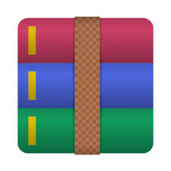AR**

Figure 1.2 WinRAR

WinRAR is a trialware file archiever utility for Windows, developed by Eugene Roshal of win.rar GmBH. It can create aand view archives in RAR and ZIP format and can unpack several archive formats. To test Archieve Integrity; it uses CRC32 and BLAKE2 checksums. It is written on C++ and was released for WinXP firstly. It supports IA-32 and x64 platformsa with an effective file size 2MB. It is multilingual and is released only for Windows. The authors has several other tools named RAR for Windows. The author several other tools named RAR for Android. MacOS, Linux, FreeBSD, MS-DOS.

Features:

* It can create RAR, ZIP.
* It can unpack ACE, ARJ, BZIP2, CAB, G2, ISO, JAR, LHA, RAR, TAR, UUE, U2, Z, ZIP, ZIPx, 7z, 001(split) archives as well as executable archives.
* It supports mulit-threaded CPU decompression .
* It can support checksums of ACE, ARJ, BZIP2, CAB, G2, RAR, XZ, ZIP and 7z.
* Supports a maximum file size of 16 EIB or 18 million TB.
* Optimal encryption using AES with a 256 bit key.
* Optional Quick Open Record to open RAR faster.
* Ability to create split and self extracting files.
* Supports NTFS hard and symbolic links, advanced NTFS File systems.

Drawbacks:

* Trialware, functionality unavailbale after a time period.
* Compression Dictionary is limited to 256 MiB in 32 bit Windows.
* Self extracting archives created before v5.31 is vulnerable to DLLhijacking.
* Versions before 5.21 had Remote Code Execution facilitating remote attacks.
* It cannot create file archives other than RAR and ZIP.
* It cannot extract all archives.
  + 1. **7Zip**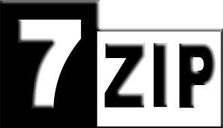

Figure 1.3 7Zip

7Zip is the most popular, free, Open source archiever developed by Igor Pavlov in 1999. It features its own 7z formats along with several other formats. It has a CLI as well GUI. Mostly Opensource GNU LGPL License with an exception UnRAR. It is written in C++. Windows, Linux, macOS, Multilingual array of 86 languages. Which is much more than other applications in the list.

Features:

* Create, edit and extract archives like 7z which uses several algorithms like bzip2, PPMd, LZMA2 and LZMA.
* 7z was rated 17% better than ZIP.
* It features several compression like ZIP, gzip, bzip2, xz, tar, WIM, 7z.
* It could decompress APM, ARJ, CHM, CPIO, DEB, FLV, JAR, LHA, LZMA, MSL2, Officeopen XML, one PKG, RAR, RPM, smzip, SWF, XAR and Z archives.
* GranFS, DMS, FAT, HFS, ISO, MBR, NTFS, SquashFS, UDF and VHD images.
* Supports 256 AES cipher system.
* Multicore CPU scheduling.
* Unpacking archives with corrupted filenames.
* Creates self extracting single volume archives.

Drawbacks:

* Cannot control file order inside archives.
* Can only unpack ZIPx formats.
* It cannot open all MSI formats.
* While compressing ZIP, gZIP, 7zip uses DEFLATE algorithm which achieves higher compression but at the cost of speed.

Thus, the softwares to be compared with, were chosen to be WinRAR, WinZIP and 7Zip. While one is an overrated underperforming software, another is a mediocre everydayware and the other is a high performing underrated free and open-source software. This software and their collective feature set helped us receive a clearer insight on what features prevail and what is unnecessary as we develop a new software that aims at changing the general look of Lossy Compression software.

**2. DESIGN TOOL**

**2.1 DESIGN TOOLS**

A design tool is any open source or proprietary software that aids a developer, designer or marketers in making a graphical drawing or design an interface. Design tools are objects, media, or computer programs, which can be used to design. They may influence the process of production, expression and perception of design ideas and therefore need to be applied skillfully. A design tool is an integral part of the design process. Some popular design tools are Adobe Photoshop, Adobe Illustrator, Sketch 3, AUTOCAD,etc.

The need for a design tool was mandatory as it drives the design process. The problem with normal Design tools is that it is mostly Mac OSX based and are not usually developed for Windows. Not having a Mac drastically downscaled out available design choices. But, that was when we came to know about Adobe XD and its simple yet powerful interface. Adobe XD proved to be the perfect development platform for our design purposes.

**2.2 ADOBE XD**

Adobe XD is a user experience design software application developed and published by Adobe Systems. It supports vector design and website wireframing, and creating simple interactive click-through prototypes. Adobe first announced they were developing a new interface design and prototyping tool under the name "Project Comet" at the Adobe MAX conference in October 2015.The first public beta was released for macOS as "Adobe Experience Design CC" to anyone with an Adobe account on March 14, 2016. A beta of Adobe XD was released for Windows 10 on December 13, 2016. On October 18, 2017, Adobe announced that Adobe XD was out of beta.

Figure 2.1 Adobe XD

For our designing purposes, we use Adobe XD. Design and development would primarily focus Mobile devices because their limited storage capacities lead to the usage of ready to use Lossy compression software. We proposed a new approach towards File compression by uploading a digital signature of the file to be compressed by a lossy algorithm to a server and then retrieving that signature at the time of decompression. We believe Adobe XD is a very good tool to start interface designing and prototyping to develop an interface that can either implement the proposed approach or create a demo interface that can simulate the complete tool but with minimum functionality.

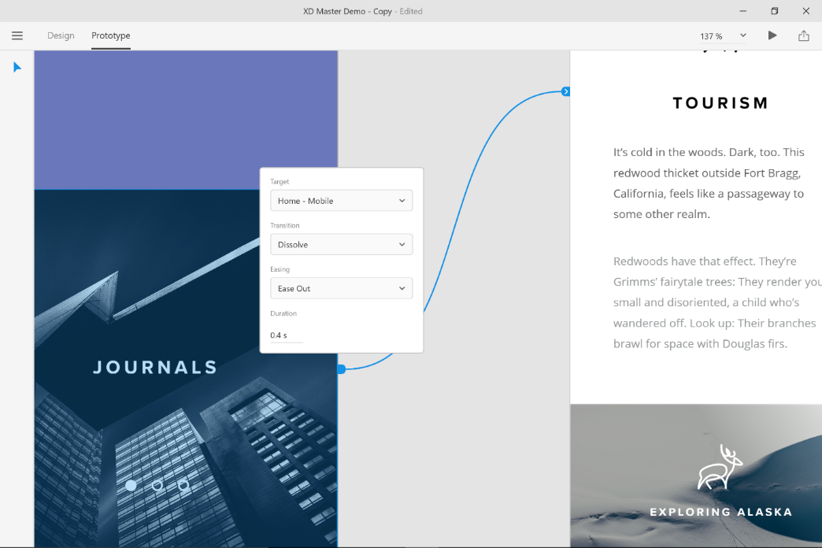

Figure 2.2 Adobe XD Interface

**2.2.1 Adobe XD : Features**

Adobe Experience Design CC, or Adobe XD, is a lightweight vector graphics editor and prototyping tool that was announced at Adobe MAX 2015 as Project Comet**.** Prototype management. UI resources, Blur effects, Versatile linear gradients, Typography styling and various other design features. Dropbox preview for XD files, Batch export, Easy integration with Photoshop, Work with Sketch files and several other pre and post designing features. These are just few of the several thousands of features built into the Software.

Developer(s) : Adobe Systems

Stable release : 13.0.12.14 / October 15, 2018; 21 days ago

Operating system : Windows 10 v1703 or later

macOS 10.12 or later

iOS 10 or later

Android 5 or later

Available in : English, French, German, Japanese, Korean, Chinese

License : Freemium

Website : adobe.com/products/xd.html

Adobe XD has a very huge feature size and this accounts for most of its scalability options. The tool can be employed for desiging and prototyping with ease. The latest version changelog is the following:

* Voice triggers and speech

Interact with your prototypes like never before. Voice triggers and speech playback let you take users beyond the screen.

* Plugins

Extend the functionality of Adobe XD for workflows and integrations with the growing collection of plugins created by our developer community. Easily discover and manage those plugins from within the app to automate tasks, integrate with other tools, design with data, and more.

* App integrations

Adobe XD now integrates with more of your favorite collaboration and productivity apps, including Slack, JIRA, and Microsoft Teams.

* Auto-animate

Auto animate micro-interactions across artboards. When you duplicate an element and change its properties (e.g. size, position, color etc.), XD bridges the differences to automatically generate an animation.

* Linked symbols

It’s easier to stay on top of changes when symbols copied from one document and pasted into prototypes remain linked. Now, when changes are made to the source file, you’ll be notified and have the option to accept updates.

* Easy integration with Adobe Illustrator

Bring your Illustrator designs and assets into Adobe XD in a snap. Just open your Illustrator file from right inside XD and it will automatically convert into a new XD file, retaining artboards, layers, and editability.

* Export to Adobe After Effects

Export your designs and take your animations even further with After Effects, the industry-leading animation tool.

* Prototype drag gestures

Now you can include drag gestures in your prototypes to simulate user experiences like dragging cards or screens.

* Redesigned home screen

Access plugins, UI kits, app integrations and more — all from one screen.

The minimum system requirements for Adobe XD is:

Operating system Windows 10 Creators Update (64-bit) – Version 1703 (build 10.0.15063) or later. For information on upgrading your Windows OS version, see How to get the Windows 10 Creators Update.

Processor Multicore Intel processor with 64-bit support with 1.4 GHz

Display 1280 x 800

Internet Internet connection and registration are necessary for required software activation, validation of subscriptions, and access to online services.

Voice capabilities require users to be connected to the internet to preview their prototypes.

RAM 4 GB of RAM of which 2 GB of available hard-disk space for installation; more free space required during installation

Graphics Minimum Direct 3D DDI Feature Set: 10. For Intel GPU, drivers released in 2014 or later are necessary. To find this information, launch “dxdiag” from the Runmenu and select the “Display” tab.

**Pros:**

* Starting. As soon as you open XD it offers you canvas sizes according to the devices you are designing.
* Interface is very clean.
* Filling UI with content is very simple. Image overlays are simple drags and drops.
* Repeat Grid feature is amazing. One can select the group and adjust the grid where you want it to be repeated.
* Prototyping is amazing! You don’t need any extra plug-ins or services to create high fidelity clickable prototype.
* Resizing Text works similar to Photoshop and Illustrator.

**Cons:**

* Repeating objects doesn’t work as you expect it as in every other vector based software. Ctrl+D doesn’t really work the way you want it to.
* Animating UI is difficult compared to Sketch.
* No CSS export. Unfortunately there’s no way to extract CSS code from your design to simplify the work for developer.
* Prototype live preview is great. But there’s one problem with this. Previewing prototype live on your smartphone works only with Mac.

**3. FEATURE STUDY AND COMPARISON**

**3.1 FEATURES IDENTIFIED**

The comparison between each individual compression software was carried out delicately and all the while paying attention to increase the aesthetic value of LossBACK to the maximum. Since this was carried out using compression software, their compression ratios and speeds in their native compression formats as well as each individual app’s capacity to replicate the same algorithms used in the other software, but with difference in their compression ratios and speeds were marked. Since comparison of all software should be carried out on the absolute level, the following features were kept as the standard for performing the comparison.

**Features:**

1. Compression formats supported: It isn’t that lesser known compression formats are being used for every day compression, but, chances are, every now and then, a person is provided a compression request on a format he has no idea about. So, the compression software should be able to read and create this extension that even the user doesn’t recognize so that the user doesn’t have to rely on another software. Thus in general, the more formats it supports, the better it is.
2. Compression ratio in native format: Compression is done either to integrate a lot of files into one single file, or to generally compress the file to reduce its size. Thus, the more compression ratio a format has, the more it compresses.
3. Compression speed in native format: A faster compression of a file indicates a faster compressing algorithm. Generally, the speed difference between two software indicates the lesser compression ratio of the faster compressing one or the efficiency of the algorithm used for the same.

These features mark the comparison standard criteria for a compression software to better than the one it is being compared with. Apart from these, several, more obvious features like Platform independence, Language support which plays a crucial role in domain scalability of the software, Checksum integrity verification and encryption schemes, etc were taken into consideration when performing the feature study.

**3.1.1 WinZIP : Features**

It is a Compression software developed by the WinZIP international LLC and Corel Corporation and first released in April 3,1991. This is a trial-ware file archiver and compressor, meaning users are free to acquire an evaluation copy which will expire when the timer hits the mark. WinZIP is available for Windows, MacOS, iOS and Android. WinZIP 1.0 was released as a GUI frontend for PKZIP. Earlier in January 1991 Nico Mak Computing released a GUI front-end for OS/2 Presentation Manager called PMZIP. It used the OS/2 versions of the PKWARE, Inc. PKZIP and PKUNZIP programs. Originally released on CompuServe, availability of WinZip expanded across major online services, including GEnie, Prodigy and other online services. In 1993, WinZip announced the launch of its official support for customers on the Windows Utility Forum, serving over 100,000 members, providing updates and related information.

WinZIP as a whole supports 12 languages which is subpar for a widely used software. The software can be used to create .zip and .zipx formats. This accounts for the wide spread popularity of ZIP compression format merely because of WinZIP’s sheer lack of feature space when it comes to compression. The software had shown significant advancement in several other feature spaces. WinZIP supports zip, tar, gzip, compress, cab, RAR, bz2, lha/lzh, 7z, IMG, ISO, xz, VHD, VMDK , uue, xxe, MIME, Binhex. arj and arc can be added by installing an additional plug-in lhz.exe. WinZIP supports integrated FTP upload. It has ARC and ARJ support with necessary dependencies. It also powers a configurable Windows Shell integration.

**3.1.2 WinRAR : Features**

WinRAR is a trialware compression software developed by Eugene Roshal and distributed by Alexander Roshal and 22 April, 1995. Written in C++, WinRAR is a Windows-only app. The author has also released an Android app called "RAR for Android" and command-line utilities called "RAR" and "UNRAR" (widely released since autumn of 1993), available for macOS, Linux, FreeBSD, Windows, and MS-DOS. WinRAR and the RAR file format have evolved over time. Support for the archive format RAR5, using the same RAR file extension as earlier versions, was added in version 5.0; files in the older RAR file format have since been referred to as RAR4. WinRAR versions before 5.0 do not support RAR5 archives; only older versions of WinRAR run on Windows versions prior to XP, and cannot open RAR5 archives.

WinRAR supports 47 languages in total. This is much bigger than the lot WinZIP supports. The compression formats supported by WinRAR are the RAR, rar, rev, r00, r001 and RAR5. One of the features that make WinRAR standout is its Multithreaded Compression and decompression which makes the process much faster than usual. Checksum (integrity) verification for ACE, ARJ, BZIP2, CAB, GZ, BZIP2, RAR, XZ, ZIP and 7z archives are provided. WinRAR supports decompression of ace, arj, bzip2, cab, gz, iso, jar, lha, rar, tar, uue, xz, z, zip, zipx, 7z, 001 (split) archives, checksum verifications almost all of the above.

**3.1.3 7ZIP : Features**

7Zip is a freeware file archiver and compressor developed by Igor Pavlov and released in July 1999. Having come to an industry owned by WinRAR and WinZIP, the features that made 7zip standout from the rest of its rivals is its usage of DEFLATE algorithm generally accounting for much more compressed files. Available for Windows, Linux, macOS, ReactOS.

The program can be used from a command-line interface as the command **p7zip**, or through a graphical user interface that also features shell integration. Most of the 7-Zip source code is under the GNU LGPL license; the unRAR code, however, is under the GNU LGPL with an "unRAR restriction", which states that developers are not permitted to use the code to reverse-engineer the RAR compression algorithm. By default, 7-Zip creates 7z-format archives with a .7z file extension. Each archive can contain multiple directories and files. As a *container* format, security or size reduction are achieved using a stacked combination of filters.

7zip has support for 86 languages and can compress and decompress using multiple CPU-cores. 7Zip supports ZIP, Gzip, bzip2, xz, tar and WIM. APM , ARJ , CHM , cpio, DEB , FLV , JAR , LHA/LZH , LZMA , MSLZ, Office Open XML , onepkg , RAR, RPM , smzip , SWF , XAR , and Z archives and CramFS , DMG , FAT , HFS, ISO, MBR , NTFS , SquashFS , UDF , and VHD disk images. 7Zip clearly supports much more functions and features than the other two.

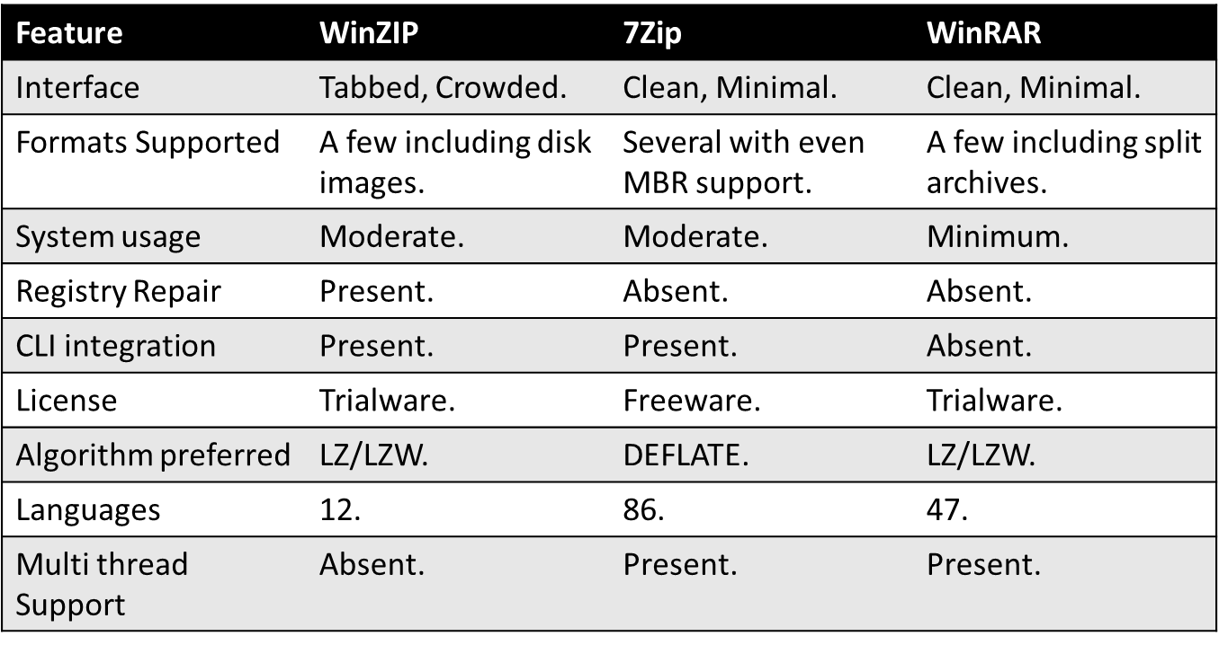

Table 3.1 Feature Comparison

**3.2 Performance Case studies**

To perform the comparison between the defined products in the criteria specified, the comparison process was divided into three case studies. Each of which account for the softwares’ performance in the aforementioned constraints. The first and second case studies compared the software on how much they compress for a defined data set while the last case study focused on the compression speed all for a given typical workload.

**Compression Ratio for heterogenous test data : Case Study 1**

Heterogenous data set consists of data that are of different formats as this is a good way of evaluating the performance of compression software. All the software was supplied with a test data comprising of various different formats to compress to their native formats. The test data was of **1.47 GB** of data  videos (different formats), images (RAW and other formats), documents (PDF, Office files, etc) and music files (MP3, M4A, etc) and passed them through each compression utility with default settings.

The Compressed output returned by each of the Softwares were as follows:

WinZip - **1.20 GB** (18.3% reduction).

WinRAR - **1.16 GB** (21.0% reduction).

7-ZIP - **1.11 GB** (24.4% reduction).

It is clear that 7zip supplies the most compressed file from all three. This result is because 7zip uses DEFLATE algorithms instead of traditional LZW algorithms that prefer compression speed over compression ratio. in terms of just compression ability, 7-Zip is the clear winner. 7-Zip has been around for a while and they have ranked at the very top for best compression utility on multiple third-party tests, so the numbers are not really surprising. The only issue with programs like 7-ZIP and WinRAR, both of which did the best in compression, is that they use proprietary formats that are not fully supported on other systems. In order for someone to open a 7-ZIP or WinRAR file, they will need to download and install the appropriate software on their machines first.

**Compression Ratio for homogenous test data: Case Study 2**

Homogenous data set consists of data that are of same format. Sine this is uniform data, the compression algorithm will be able to perform much more efficiently. All the softwares were supplied with a data similar to that in Case Study 1.

The test data comprised of **1.3 GB** of uncompressed video files and were compressed using their native compression formats. This was tested using their best compression settings rather than the default ones for each program.

The compressed output were as follows:

WinZIP - .Zip: **855 MB** (34% compression)

.Zipx: **744 MB** (43% compression)

WinRAR - .rar: **780 MB** (40% compression)

.rar5: **778 MB** (40% compression)

7zip - .7z: **758 MB** (42% compression)

It is evident from the provided results that 7Zip performs significantly better than both other Software. The 1% difference in compression levels between it and the technical “winner” WinZip aren’t nearly enough to warrant forking out money for it.

**Compression Speed in native formats : Case study 3**

The data set is composed by various standard test files and the software were asked to compress this data using their native compression formats. The data set provided was heterogenous data of 134 MB size.

The output file was observed as follows:

WinZIP(.zip) - 18.7s

WinRAR(.RAR) - 23.6s

7Zip(.7z) -  79.5s.

WinZIP has a much faster compression speed in its native compression format. This is because of the very low compression ratio of ZIP compression that makes ZIP format provide good speed.

**3.3 FEATURES ADAPTED**

A smart compression approach that allows users to use reproduce original files even after using lossy compression techniques. Allowing users to use lossy compression techniques in place of lossless techniques. This involved sending the file to a remote server where the uploaded signature only contained the redundant bits from the original file.

Providing a quick preview of compressed files. This is achieved by using an emulated cache and storing it in the cache and as the decompression proceeds, slowly developing the file as it gets decompressed.

Minimum noise included in the GUI so as to reduce the level of distractions.

1. **USER EXPERIENCE AND ANALYSIS**

**4.1 Methods of UX Analysis**

UX Analysis was carried out by conducting a survey among an audience that composed of several Tech savvy non computer scientists that relied on Compression Software for daily usage. The audience was made more even by asking people from different countries like Russia, India, UAE etc. The UX Analysis composed of 3 parts:

1. Software Selection:

This was to make sure that the software we chose to compare and expand upon were actually good and popular software. This would help us downscale the actual feature space and focus on relevant features rather than focusing on reduntant and less popular features. The question asked was the following:

Which Compression Software do you use on a day to day basis?

-WinRAR

-WinZIP

-7Zip

-PeaZIP

-Others

1. Feature Preference:

This helped show what direction our development had to go. If focussing on Compression ratio would backfire or progress as a relevant development topic.

The compression approach we proposed was focussed on Compression ratio and we were expecting more positive responses towards the same. The question in the survey was the following:

Do you prefer Speed of Compression over Compression Ratio?

-Yes

-No

-Maybe

1. Feature Review:

This was carried out to see if Pseudo Lossless Compression was actually a good idea to work on, we also asked the people regarding the Expectations or Privacy concerns they had as users. This would help shape development in the right direction as well as update the developmental aspects as well as the Privacy Policy. It would later turn out that this question addressed several of the security concerns people had. The question asked was the following:

Would you prefer a new compression technique over a conventional one if the new one offers no data loss and can still provide a better compression ratio but uploads a digital signature of the data to some server(which is just bits thats are of no use to the admin) to aid the restoration process, guaranteed your privacy won't be compromised?

-Yes

-No

-No. I’m resistant to change.

-Maybe

We made projections on how each question might be attended. The target audience comprised of People who use Compression software or have some insights on how it works. This audience was mainly students, professors, designers, etc, from several age groups and countries. The survey lasted a week from 30th Aug to 6th Aug. The survey accepted 100 responses.

**4.1.2 User Surveys**

-Software Selection:

Which Compression Software do you use on a day to day basis?

-WinRAR

-WinZIP

-7Zip

-PeaZIP

-Others

Projected Reviews:

- WinRAR(20%)

-WinZIP(20%)

-7Zip(30%)

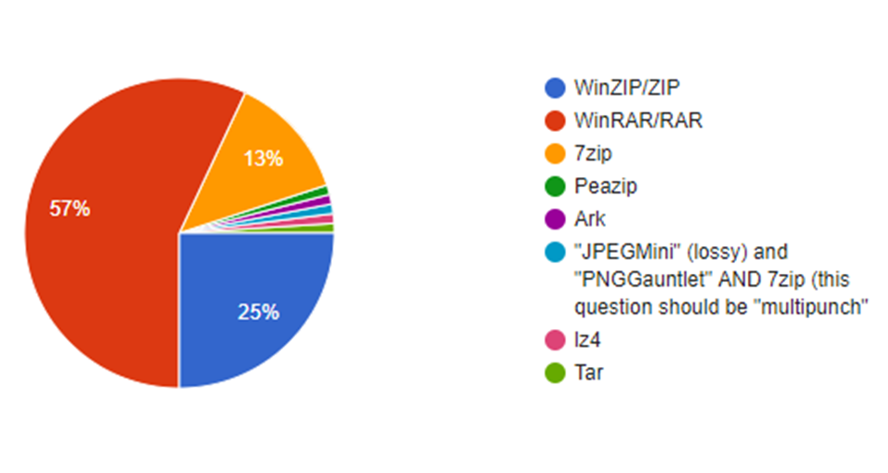 -PeaZIP(25%)

Figure 4.1 Software selection

-Others(5%)

Actual Reviews:

-WinZIP(25%)

-WinRAR(57%)

-7Zip(13%)

-PeaZIP(1%)

-Others(4%)

- Feature Preference:

Do you prefer Speed of Compression over Compression Ratio?

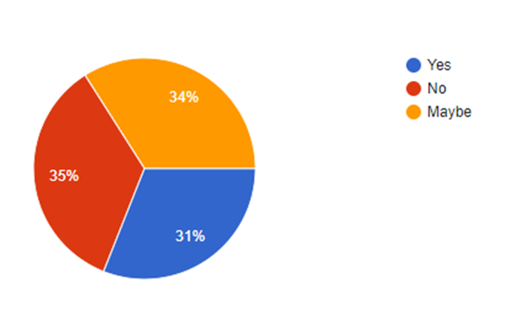-Yes

Figure 4.2 Feature preference

-No

-Maybe

Projected Reviews:

-Yes(40%)

-No(40%)

-Maybe(20%)

Actual Reviews:

-Yes(31%)

-No(35%)

-Maybe(34%)

-Feature Review:

Would you prefer a new compression technique over a conventional one if the new one offers no data loss and can still provide a better compression ratio but uploads a digital signature of the data to some server(which is just bits thats are of no use to the admin) to aid the restoration process, guaranteed your privacy won't be compromised?

-Yes

-No

-No. I’m resistant to change.

-Maybe

Projected Reviews:

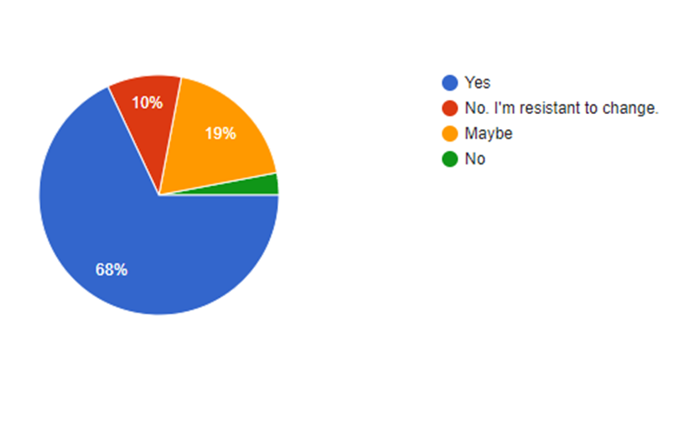

Figure 4.3 Feature review

-Yes (70%)

-No (10%)

-No. I’m resistant to change. (5%)

-Maybe (15%)

Actual Reviews:

-Yes(68%)

-No(3%)

-No. I’m resistant to change(10%)

-Maybe(19%)

-Some User Reviews:

If you answered maybe to the previous question, please specify why:

* + depends highly on usecase, since compression ratio is a tradeoff with time. (e.g. zopfli is 80 times slower than normal zip, from the top of my head) this is perfectly fine for hightraffic stuff, but certainly nonsense for "sending a zipped file to someone"... Also for question 2, its a tradeoff, with a slow connection, i usually am fine to invest a bit more in compression, as its slower than linespeed. however, other usecases, for example from ram to disk, often a fast compression gives most speed...
  + Resistance to Change.
  + So then u need an internet connectivity to access files?
  + The recovery process will require internet access. Which is not favourable. Its not the "resistance to change“.
  + Speed can be helpful for the users
  + Feel like a cyber security threat
  + It depends on the content.
  + can i know why are you storing signature of the data in your server ? what is your use ? anyway all the best for your project ! ( anandu.in )
  + Just don't trust it.
  + I can never compromise privacy.
  + Privacy has to be compromised.

**4.2 Analysis of Survey Respones**

Software Selection:

The projections were way off. This forced us to switch from PeaZIP to WinZIP.

People aren’t very aware of the best software available. Even though 7Zip is much more advanced in terms of features and is free to use, people still use other Trialwares. WinRAR is overrated. PeaZIP is very underrated. There is resistance to change. People use the conventional methods over newer Applications.

Feature Preference:

Projections were somewhat correct. People were almost indifferent about speed or ratio of compression. This would highly depend on the use-case. The review was a little bit biased towards Ratio.

Feature Review:

Projections were almost correct. People are mostly happy to have such a feature. There were more people who were resistant to change than projected. For success of the project, it is necessary to spread awareness among the users. People are skeptical of privacy measures

People really worry about their privacy. They don’t really think it is a good idea to make the project internet connection necessary. It can also be noted that some are resistant to change.

**4.2.1 Impacts on Current Features**

Software:

Despite its features, PeaZIP has yet to be popularized among the userbase. This would show that people are basically not very entertained by new applications even though they offer better features, Also, Windows by default has a decompression software. People are mostly not interested in Installing a new one. WinZIP is a more prefered software despite being a trialware. WinZIP is well known for being cracked very easily due to outdated extensions at every hacker’s disposal. Also, the widespread popularity of the software is mostly due to piracy and the infamous infinite free trial.

Privacy:

People are worried if we will collect data from them. They mostly wont take someone’s word for their security. Even though it was clearly advertised that the application will have no security flaws, people are not ready to accept the software unless some proof of concept is provided to them. This involved us to rush the development of a prototype or rather an Interface that appealed the Users.

Network:

The always online concept is not a preferred one. People are not always likely to be connected to the internet. This is the issue in most cases where the app demands a steady internet connection but the link was weak. So there is a chance for data to be lost half-way or as a whole. This forced us to employ counter measures against such a loss or attack.

**4.2.2 Changes Adopted**

Change the comparison Software. The comparisons drawn from PeaZIP appears to be pointless due to its tiny userbase. We chose WinZIP over PeaZIP. This gave us a significant advantage due to WinZIP’s small feature space and Propreitary license. Also, the feature space was vastly downscaled as most of PeaZip’s powerful features were deemed unworthy of the competition. Also, most features offered by WinZIP are useless in the compression point of view.

Spread a general awareness about the privacy protection we ensure. The signature file created does not contain any sensitive info , but just reduntant bits from the file. It will be impossible for anyone to make out the actual document from the digital signature uploaded and this helped shape a transparent privacy policy. Also, as much attention to privacy policy was addressed, automatic crash logs were sent anonymously. This ensured were up to par with the other software we were competing with.

Instead of always online approach, we propose a new approach, Only upload the signature when connected to the internet. Create a signature file in the storage and clear it when uploaded. This would help reduce the traffic issues and storage management in both the server side as well as the Client side. The signature file kept locally will be of little size and this will be discarded. This ensured a fast and reliable uploading technique. The signature will be stored in the secondary storage to be safe from crashes etc.

**5. GUI Design**

**5.1 USER INTEFACE COMPARISON**

User Interface (UI) Design is the link between users and an application. It includes the basic design elements that need to be present in order to for navigation in the application and make decisions. Basically, the significance of a UI is the communication from a product to the user and vice versa. UI Design is all about structure, user manipulation and communication. This is one of the reasons it’s so important that close attention be paid to it. One thing that takes people by surprise is how big of an impact even the smallest adjustments in UI Design can have. Design speaks to people and should be taken seriously if the app is to be successful.

Usable Security measures have to be adopted while developing a visually appealing, secure UI. Usability testing as well as Extensive UI comparison needs to be performed to create an ideal UI. Thus, the Interface Comparison Study was performed and the results tabulated. The Interface Comparison was performed among PC application and Android in three phases:

1.Logos

Logos are the primary attention grabbers when a User just starts getting familiar with a new application. It was found that the logos of several of the applications remained the same as they were when they were first released. This were rather ugly 256 colored retro icons. Thus, LossBack was supposed to have a minimal greyscale logo both because it supported less battery consumption as well as save display from pixel burn ins and its minimalism.

2.Homescreen UI

Homescreen UI comparison was necessary for UI development. This is because the UI is what the user will be dealing with, for usage. This comparison was also performed extensively and summarized so as to provide a solid working ground for the design development of LossBACK. LossBACK UI will be developed so as to be as minimal and greyscale all the while being uncrowded and fast.

3.Functionality Tuning

Functionality Tuning is available for every software in the name Settings or Options. Such a tab usually incorporates all the Tunings and changes that can be performed in the software. Such a UI is to be provided so that a user can tune the software to his will. This involved available languages, scaling, themeing, etc. LossBACK will have a fully customizable UI with a feature to load presets for even UI scaling.

**5.1.1 Logo Comparison**

A Logo is a design symbolizing one’s organization. It is a design that is used by an organization for its letterhead, advertising material, and signs as an emblem by which the organization can easily be recognized, also called logotype. Logotype is a graphic representation or symbol of a company name, trademark, abbreviation, etc., often uniquely designed for ready recognition. Logos serve to represent a given organization or company through a visual image that can be easily understood and recognized. A logo generally involves symbols, stylized text or both.

Logos are often created by a graphic artist in consultation with a company and marketing experts. Business logo design is an important tool when it comes to promoting a company's products or services. But the logo must have a unique design that incorporates a design concept and colors etc. elements in a special way. Such a logo makes a lasting positive impression on the potential customers.

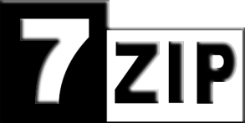

Figure 5.3 7Zip

Figure 6.2 WinZIP

Figure 7.1 WinRAR

7zip has a minimal logo. But, all others presented a rather oversaturated colored icon. Though it should be aesthetically pleasing but it isn’t. It is messy and that exactly what LossBACK isn’t aiming for. LossBACK aims to sport a minimal logo. This would be pleasing and eye catching. Greyscale logo is also a suggested feature as it doesn’t cause any pixel burn ins.

Figure 5.4 LossBACK (Early rendering)

**5.1.2 Homescreen UI**

Homescreen User Interface is basically what an application opens up to. Thus, keeping a clean and modern UI ensures a good UI experience for the user. The User Interface can be decided up on based on the comparison and extraction of the prominent features, an ideal UI can be developed. Upon performing the comparison, the following were observed.

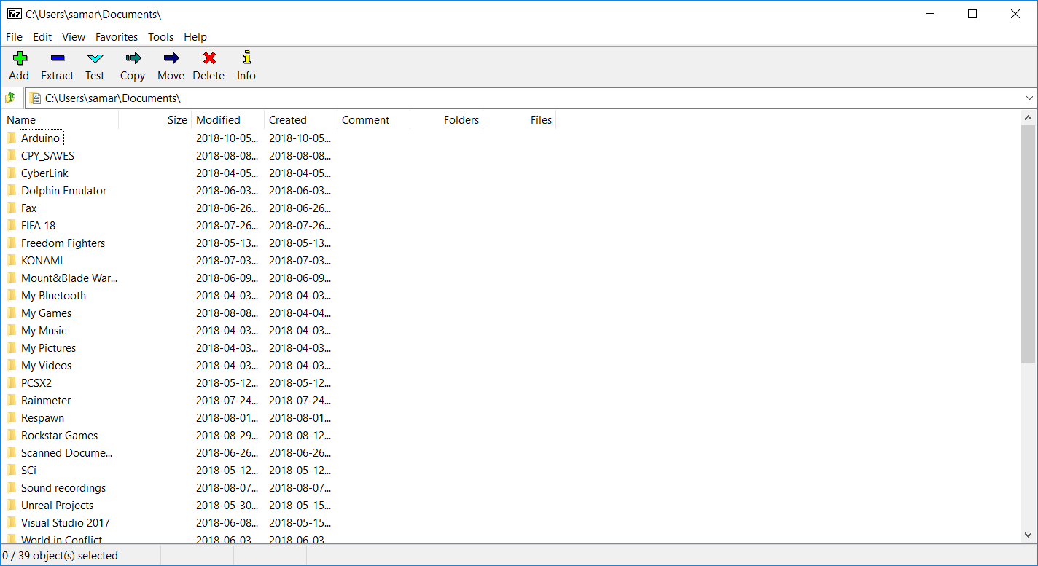

Figure 5.5 7Zip Home UI

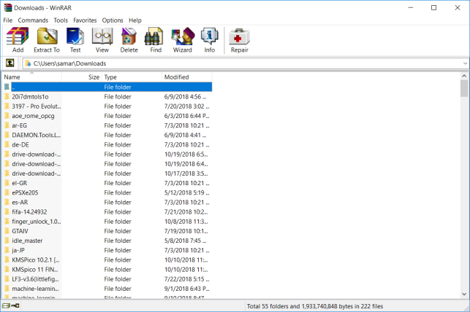

Figure 5.6 WinRAR Home UI

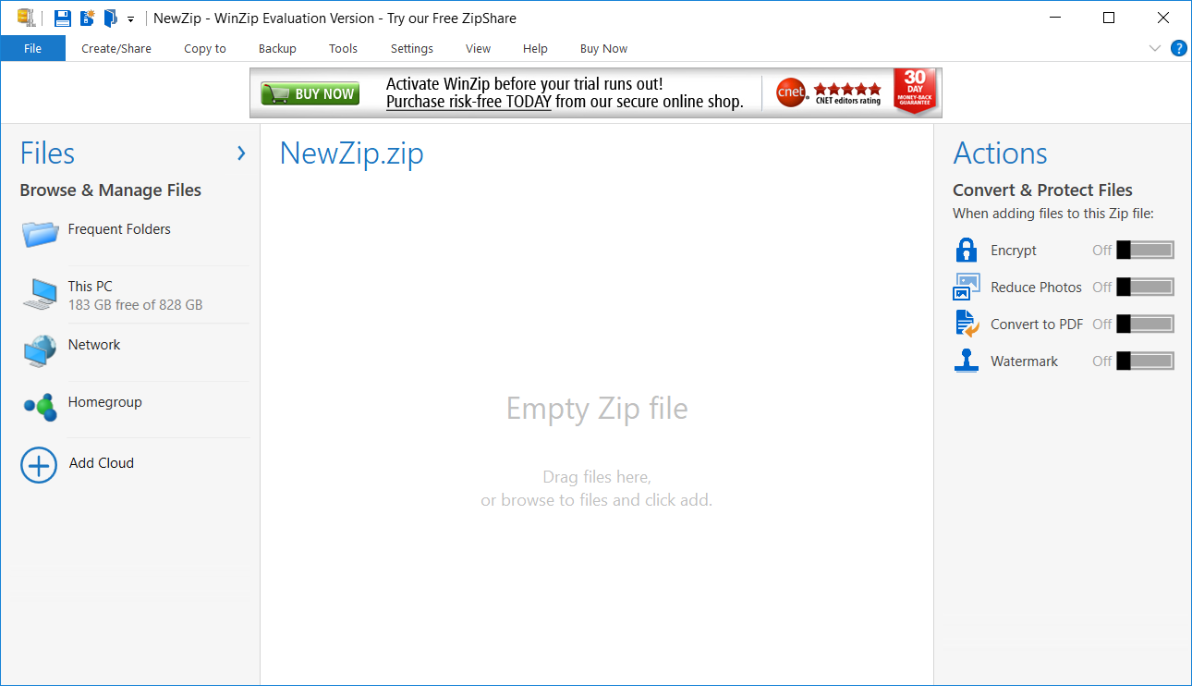

Figure 5.7 WinZIP Home UI

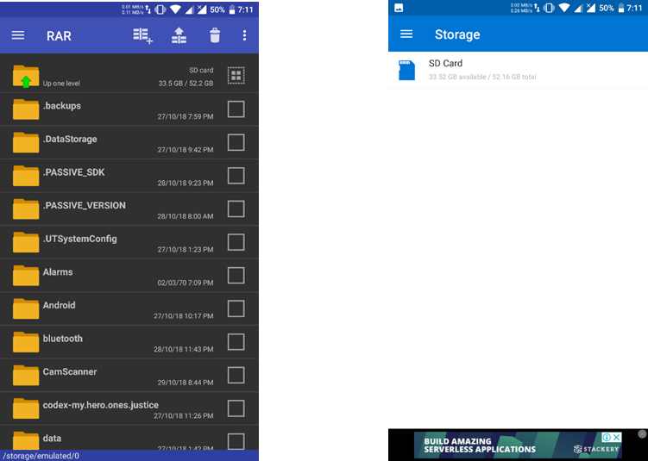

Figure 5.8 RAR Home UI Figure 5.9 WinZIP Home UI

WinZIP has a very crowded and unpleasent interface with ads about itself. Everything has a retro interface except WinZIP. Everything opens up to a recently opened directory. The installers have little adaptability to a higher resolution monitor. The Quicktab has several similar features. Thus, the quicktab seemed like a very good feature to be implemented in LossBACK for proper navigation. LossBACK will have an easily accessible sidebar instead of the traditional topbar.

**5.1.3 Functionality Tuning**

Tuning is necessary as it helps allow the app to be tuned and to be used as per the likes of a user. Almost every software has some way of Tuning the interface and functionality it has. This not only helps the user Utillity but rectifies its feature space to its maximum. When it comes to a compression software, the basic functionality tuning such as formats supported, multithreading, etc and Utility tuning such as dark mode, scaling options, etc.

Upon performing the comparison, the following were noted.

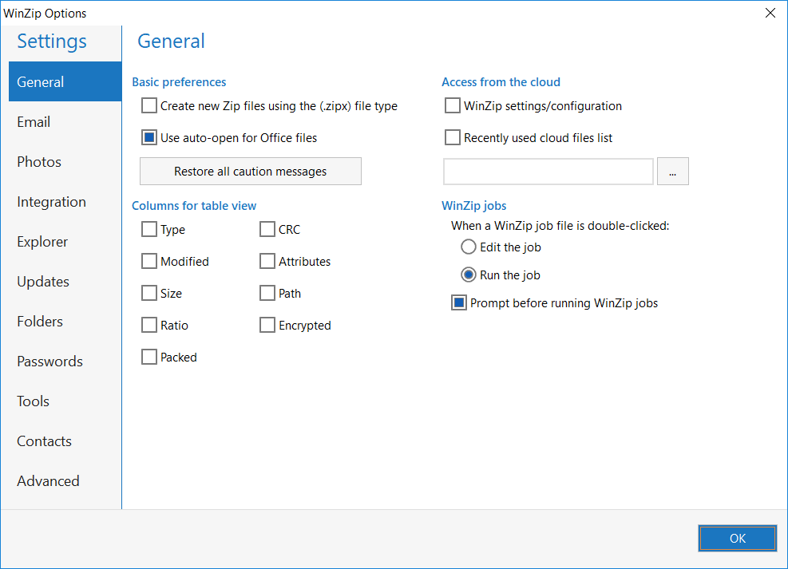

Figure 5.10 WinZIP Settings

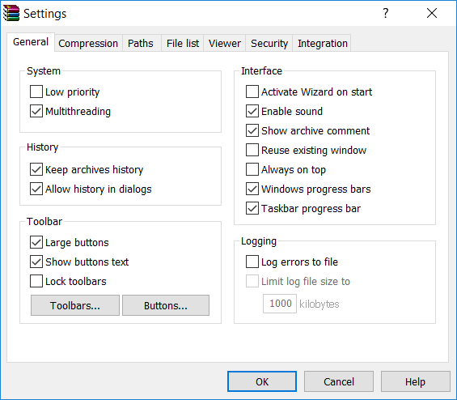

Figure 5.12 WinRAR Settings

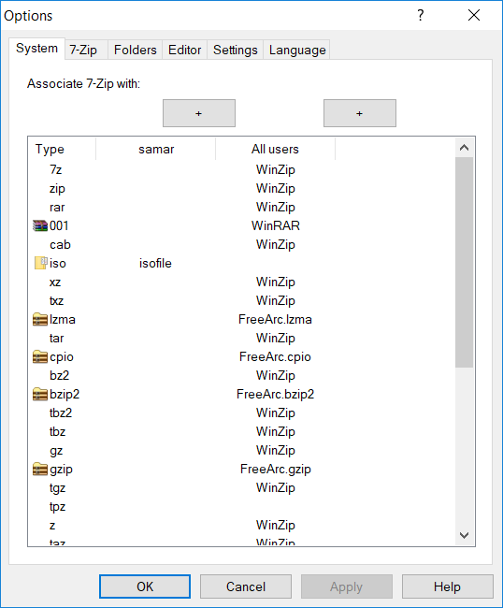

Figure 5.11 7Zip Settings

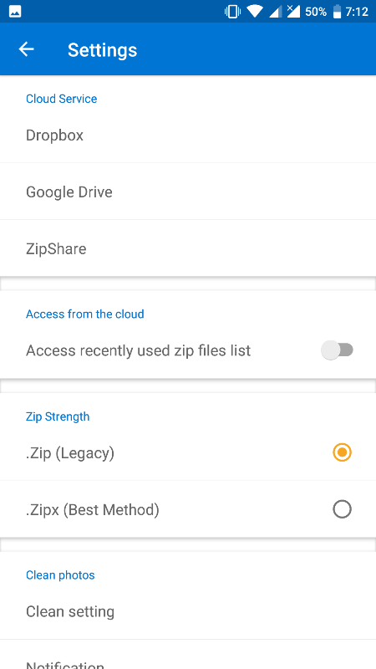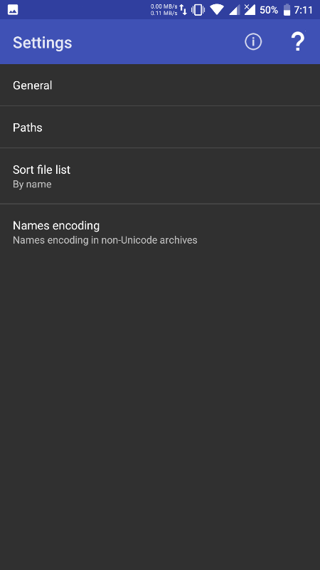

Figure 5.14 WinZIP Settings

Figure 5.13 RAR Settings

All the software had tunable basic functionality and that was it. Not much features were present and modifyable apart from the wide array of unrelated features WinZIP features.

System behavior selection is bare minimum for all applications. Language and sound selection and a few other features were scalable and editable. This was much less convenient for a typical user. No features like performance switch, Theme and font scaling were present.

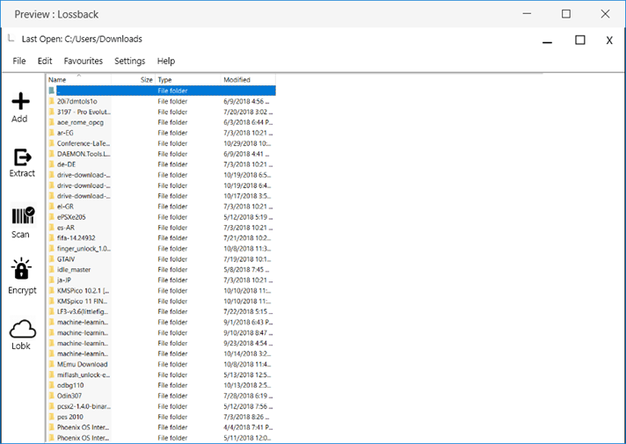 We decided to cope all this by adding all missing functionality to LossBACK. The UI is:

Figure 5.15 LossBACK Homescreen

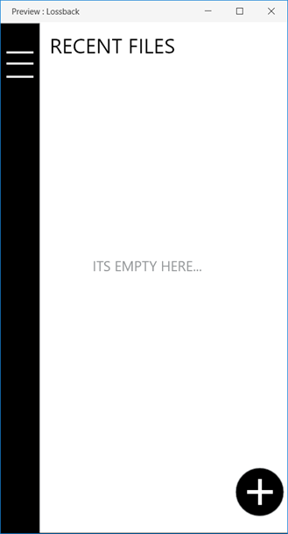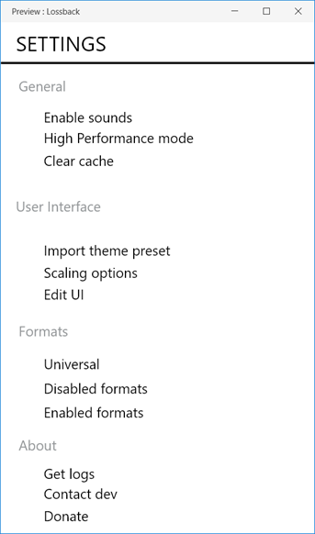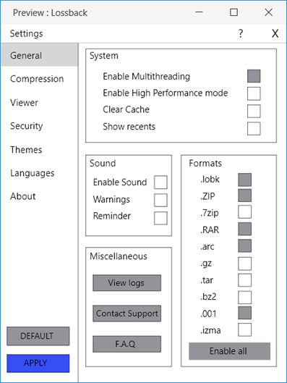

Figure 5.17 LossBACK Mobile

Figure 5.16 LossBACK Settings

Figure 5.18 LossBACK Mobile Settings

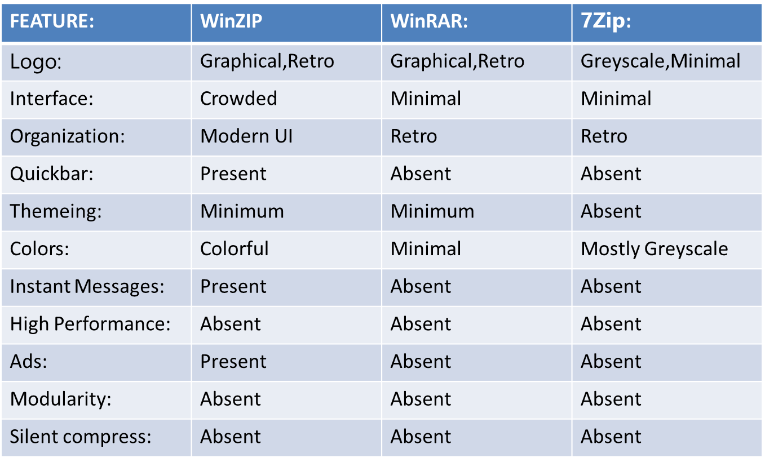

Table 5.1 Interface Comparison

**5.2 UI ADAPTATIONS**

Minimal greyscale Logo – reduces power consumption

Free Interface – Uncrowded and pleasant to use

Modern UI – against the retro UI

Quickbar with lobk browser – Server browser

Absolute themeing – Complete repainting and UI designing

Greyscale interface - reduces power consumption

High Performance mode – push all system services to stack, elevate compression or decompression jobs, pop back services

Modular features – each feature is separately developed as a module which can be detached to free RAM

Silent softcompression – Soflty compresses file silently in the background.

1. **SCALABILITY AND DEPLOYABILITY STUDY**

**6.1 SCALABILITY**

Scalability is measured in how well it performs on a scaled situation, be it the User base, feature space or region of service provision. A scalability study is mandatory to be performed for the proper operation of the software. For the same purpose , all the software were compared.

WinZIP:

Increasing user base adversly affects WinZIP as it provides cloud services. WinZIP was known to have several critical bugs. This means that feature scalability is pretty bad. Adaptability to newer formats is slow. Version history has not been updated for 6 years in the official website. Last version was released 2 years ago.

WinRAR:

WinRAR only provides simple compression/ decompression. Increasing user base would not directly affect WinRAR. Faster development than WinZIP. Updates encryption methods.

7Zip:

User base scaling wont affect 7zip. Gradual updates are pushed. It updates compression algorithms. Handles feature scaling positively.

**6.2 DEPLOYABILITY**

Deployability is how well the application can be deployed in the general userbase and the methods adopted for the same. How well a software can be deployed stands for how well it performs in a general crowd. The deployability features are as follows:

WinZIP:

Most of the user base uses the paid version of the application It has ads. It is overrated and does not have a very high compression ratio. ZIP is a very widely used extension with little compressive power. The free android version is available in the playstore. The windows version is available for download on WinZIP’s website. It only provides a short term evaluation version. The License key is to be bought for further use.

WinRAR:

The application is paid for most of its use. It is released under the WinRAR official website. The software doesn’t have an evaluation copy that expires. This gives users an infinite 30 day trial copy. The android application RAR is supplied through the play store. It has ads. .RAR is a compression method more powerful than .ZIP.

7Zip:

.7z is much more powerful than the other two. It is supplied through 7zip website. It is available in sourceforge.net. It does not have any ads and is a Free Open Source Software. Being the best of all three, it speaks for itself. .7z format is quite common for most compression software.

**6.3 ADAPTATIONS**

LossBACK will initially incorporate all of 7Zip’s existing extensions. What will make it stand out is its ability to choose between DEFLATE and LZ/LZW algorithms instead of choosing one. The initial iteration of the software will be a skeleton that can only compress and decompress files with the ability to choose between the compression algorithm and is modular and has a high resource consuming high performance mode.

Further iterations will included other features like .lobk and themeing options which are extensively advertised over. These versions will be made secure and fool proof. .lobk support requires acquiring a server, so this might take a while to set up. Later versions will incorporate silent compression which will dynamically choose the algorithm based on battery levels and resource availability. Newer extensions will be implemented correspondingly.

LossBACK will be a free and open source software; meaning anyone can get and modify its code at the base level. LossBACK is expected to have two different versions for the Windows and Android operating systems. Development to other operating systems will be based on the success rate of the aforementioned software.

The PC version of the software will have its x86 and x86_64 clients so as to extend support to 32 bit PCs. The software will be published under sourceforge.net where it can be acquired by anyone looking for the PC versions. Also, the code of the software will be kept and maintained in github. Since it is free to use and provides a cloud service, it will certainly make people intrigued. The software will have its own updater module thus making it easier to get newer extensions.

The android version of the software will be supplied via the Google Play Store services where users can find and acquire a copy. Its code will also be maintained in the github repo. Since the software supports system wide integration, the mobile application will sport most, if not all of the PC version’s capabilities. This also includes the updater.

Both versions of the software will have a closed beta program where updates are provided even earlier.

1. **PERFORMANCE ANALYSIS**

**7.1 PERFORMANCE COMPARISON**

Performance of applications were compared as they provided a much better insight of what the applications stand for, as well as how good they are in a typical scenario under daily usage. The performances were compared and conclusions thus raised help develop a more fluid as well as less demanding application for the users.

WinRAR:

High RAM usage, little RAM usage when idle Low CPU usage. Compression ratio is much lower. Average speed.

WinZIP:

High RAM usage even when idle. Average CPU usage. Slowest to load. Least compressive. Fastest as its compression ratio is very low.

7Zip:

Launches very fast. Least memory using. Very low CPU usage. Most compressing. Slowest as it uses DEFLATE.

**7.2 ADAPTED FEATURES**

LossBACK is intended to perform as fast as WinRAR or WinZIP while using an LZ/LZW algorithm and as compressive as 7ZIP in its DEFLATE mode. .lobk will be slower depending on the machines’ read and write speed and its internet connectivity. It will be as quick as any normal lossy compression method with all the same compression ratio.

It will have quick AES encryption schemes which are more secure. The checksums used for each file will be SHA-4 encrypted as it is harder to crack. The files in the server will be hashed with the checksums. So search results will be as fast as O(1). Compression speeds will be governed by internet connection’s speed. It can switch between DEFLATE and LZ/LZW when demanded. This guarantees all features of the original software.

1. **SAFETY AND SECURITY**

**8.1 SAFETY MEASURES**

User safety:

Compression software is usually safe for all aspects of its usage. Data manipulated is secure. No uploads except for cloud in WinZIP. User data is not collected unless notified. WinRAR is rumoured to sniff data but was never proven. Users are free to use apps after acquiring key or until evaluation copy expires.

No data will be collected. Cloud doesn’t use users file but redundant bits. Crash reports will be anonymous.

Data safety:

Lossless compression techniques uphold data integrity. Only lossy causes data loss. Algorithms are fail safe. Don’t usually cause data corruption. There are mechanisms to retrieve lost data after power failure.

No user files will be uploaded as a whole. Making out the file is impossible.

System safety:

Lossless compression techniques uphold data integrity. Only lossy causes data loss. Algorithms are fail safe. Don’t usually cause data corruption. There are mechanisms to retrieve lost data after power failure.

Will run-off 7zip’s source code as it is much faster. It will be less resource consuming.

**8.2 SECURITY FLAWS:**

WinZIP:

* WinZip before 11.0 allowed man-in-the-middle attacks as update authenticity wasn’t checked.
* Buffer overflow in Winzip32.exe in WinZip 9.0 allows local users to cause a denial of service.
* Buffer overflow in the WZFILEVIEW.FileViewCtrl.6 can cause remote code injection.
* Multiple buffer overflows in WinZip 9.0 and earlier allow attackers to execute arbitrary code.
* Multiple directory traversal vulnerabilities in LHA 1.14.
* Several vulnerablilities can be seen in the case of WinZIP.
* Updates are released.
* Huge feature set causes updates to be even more buggy.
* Last reported at 2009.

WinRAR:

* The file-execution functionality in WinRAR before 5.30 beta 5 allows local users to gain privileges (Trojan).
* Stack-based buffer overflow in the SFX module.
* Stack-based buffer overflow in UNACEV2.DLL.
* The Repair Archive command in WinRAR 3.40 allows remote attackers to cause a denial of service.
* Directory traversal vulnerability in WinRAR 3.42 can caused arbitrary file creation.
* Buffer overflow in WinRAR 3.50 and earlier allows local users to execute arbitrary code.
* Mostly Buffer overflows due to badly programmed modules.
* Last reported in 2015.

7Zip:

* 7-Zip implements "Large memory pages“ using which security bypass can be achieved.
* Incorrect initialization logic of RAR decoder objects causing denial of service.
* Insufficient exception handling in the method NCompress::NRar3::CDecoder::Code causing DOS attacks.
* Heap-based buffer overflow in the NCompress::NShrink::CDecoder::CodeReal causing DOS attacks.
* A null pointer dereference causes DOS attacks and crash.
* Last report on 2018.

1. **MAINTENANCE AND HANDLING**

Software maintenance is a part of Software Development Life Cycle. Its main purpose is to modify and update software application after delivery to correct faults and to improve performance. Software is a model of the real world. When the real world changes, the software requires alteration wherever possible.

Software maintenance is a vast activity which includes optimization, error correction, deletion of discarded features and enhancement of existing features. Since these changes are necessary, a mechanism must be created for estimation, controlling and making modifications. The essential part of software maintenance requires preparation of an accurate plan during the development cycle. Typically, maintenance takes up about 40-80% of the project cost, usually closer to the higher pole. Hence, a focus on maintenance definitely helps keep costs down.

LossBACK uses a dedicated server. Server will be updated regularly with new AES keys. Files will not be localized to reduce chances of attack. Updates will be pushed to Beta testers Weekly. Stable updates will be pushed monthly. Files will be deleted upon retrieval to prevent Storage overheads.

1. **COST AND PRICING**

The project cost is a cost required to procure all the needed products, services and resources to deliver the project successfully. No project starts without a budget. Project success is decided by how well the project cost has been handled in the project. Many times it happens that, the project may not be completed within the project cost. It means that when compared the Project Cost Vs Project Profit, Project Cost might have exceeded and it is of course considered as a project failure.

Hence it’s very important to come up with the correct cost estimation needed for the project. To come up with accurate cost estimation, it’s requiring to understand the types of project costs involved in the project.

Calculating Total Project Cost (TPC) is a vital step for any project. If Total Project Cost is not estimated precisely, the project will have to face serious consequences. It will have a direct impact on the project schedule, quality, and scope. This will lead to cost overrun.

Since Initial Build runs off 7zip source code, Resource usage is minimum. It will be a freeware. Grey scale and silent compress reduce usage drastically. Server usage will be minimum as files are removed on retrieval.

1. **DEVELOPMENT OF DESIGN**

**11.1 DESIGN**

One framing of the engineering design process delineates the following stages: research, conceptualization, feasibility assessment, establishing design requirements, preliminary design, detailed design, production planning and tool design, and production. Others, noting that "different authors (in both research literature and in textbooks) define different phases of the design process with varying activities occurring within them," have suggested more simplified/generalized models - such as problem definition, conceptual design, preliminary design, detailed design, and design communication. A standard summary of the process in European engineering design literature is that of clarification of the task, conceptual design, embodiment design, detail design. In these examples, other key aspects - such as concept evaluation and prototyping - are subsets and/or extensions of one or more of the listed steps. It's also important to understand that in these as well as other articulations of the process, different terminology employed may have varying degrees of overlap, which affects what steps get stated explicitly or deemed "high level" versus subordinate in any given model.

The Design Process is an approach for breaking down a large project into manageable chunks. Architects, engineers, scientists, and other thinkers use the design process to solve a variety of problems. Use this process to define the steps needed to tackle each project, and remember to hold to all of your ideas and sketches throughout the process.

The design process consists of 6 steps:

1. Define the Problem

You can’t find a solution until you have a clear idea of what the problem is.

2. Collect Information

Collect sketches, take photographs and gather data to start giving you inspiration.

3. Brainstorm and Analyze Ideas

Begin to sketch, make, and study so you can start to understand how all the data and information you’ve collected may impact your design.

4. Develop Solutions

Take your preliminary ideas and form multiple small-scale design solutions.

5. Gather Feedback

Present your ideas to as many people as possible: friends, teachers, professionals, and any others you trust to give insightful comments.

6. Improve

Reflect on all of your feedback and decide if or to what extent it should be incorporated. It is often helpful to take solutions back through the Design Process to refine and clarify them.

**11.2 BASIC UI DESIGN**

Basic UI design composed of the first page the software opens up to. This is one of the most aesthetically pleasing features of the UI. The ability of the software to stand out from the rest of the crowd itself was a great measure of how well the design proposed turned out. Thus, a minimal greyscale logo and greyscale application was developed.

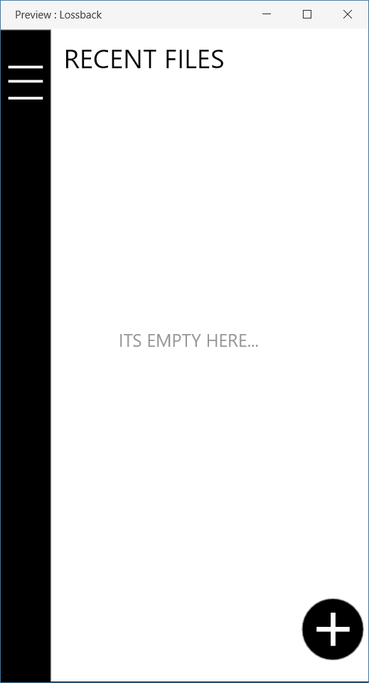

Figure 11.2 LossBACK Mobile Home UI

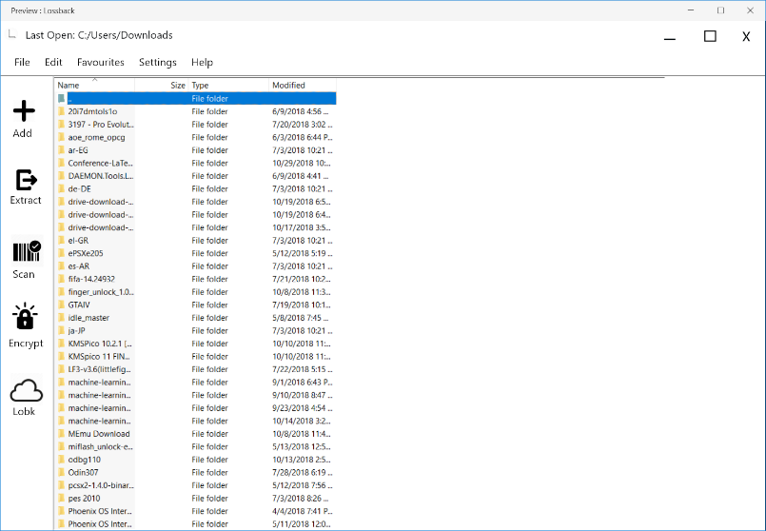

Figure 11.1 LossBACK Home UI

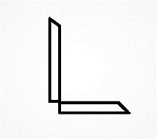

Figure 11.4 LossBACK Early Logo

Figure 11.3 LossBACK Final Logo

The development process was carried out using Adobe XD. An initial logo was developed. But since it was too dull, we went for the new logo. Development in XD helped create a good prototype very easily.

**11.3 FEATURE MANIPULATION UI**

The feature space of LossBACK addresses several of the features that were introduced to the software throughout the development life cycle. This involes Quick preview; where the file being decompressed is regularly reproduced in an emulated cache or sort and this file can be displayed to the user upon demand. Other features like Silent compress, as well as some generic compression / decompression features were discussed here.

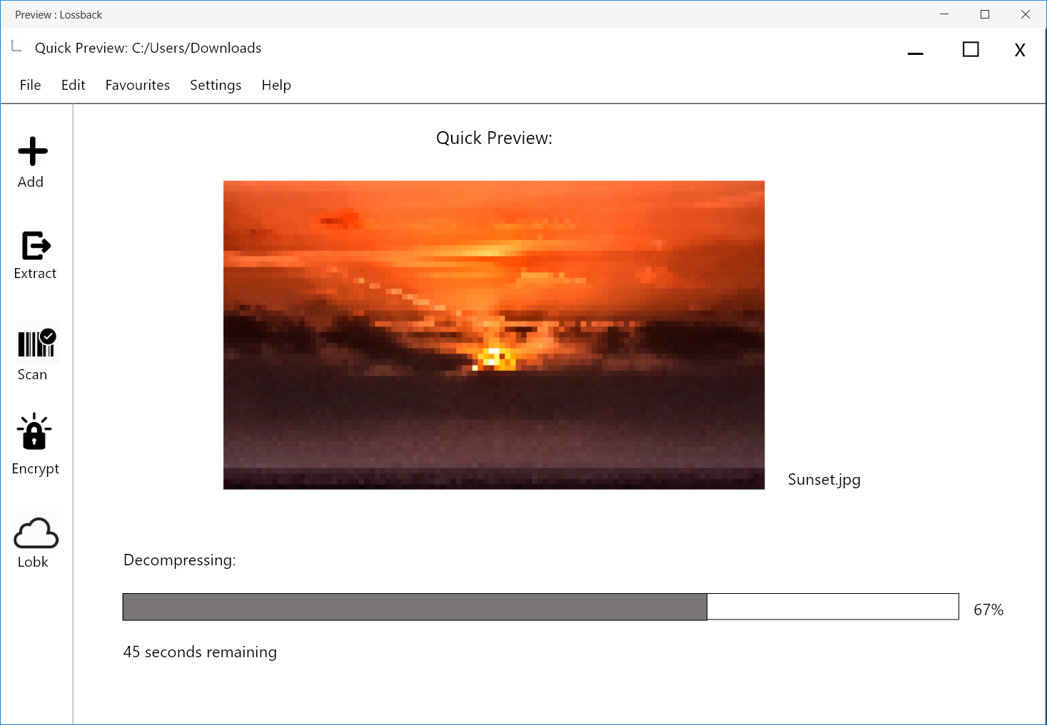

Figure 11.5 Decompression in Desktop

Figure 11.6 Encryption in Desktop

Figure 11.7 Scanning in Desktop

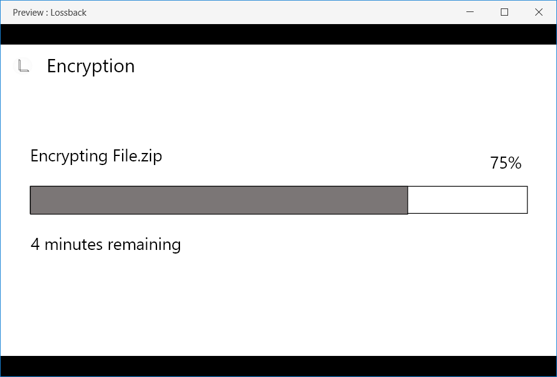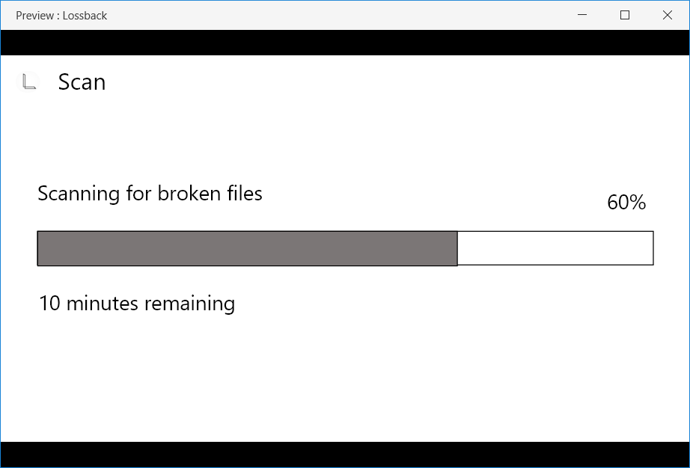

Figure 11.6 Encryption in Desktop

Figure 11.7 Scanning in Desktop

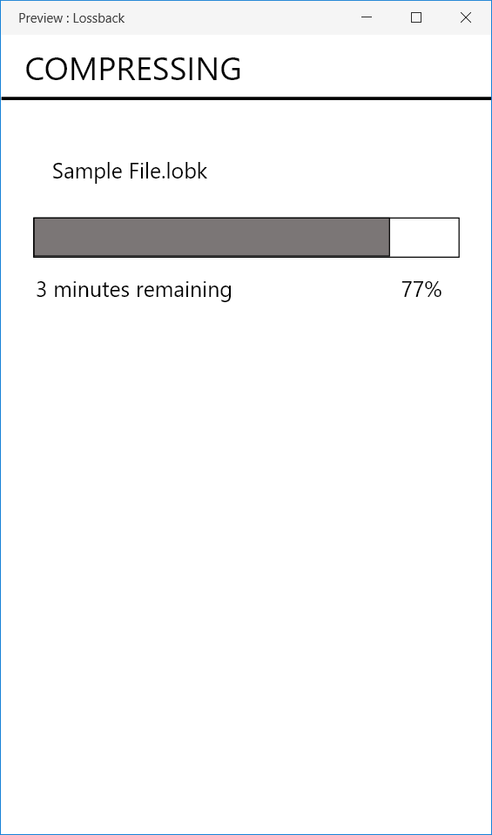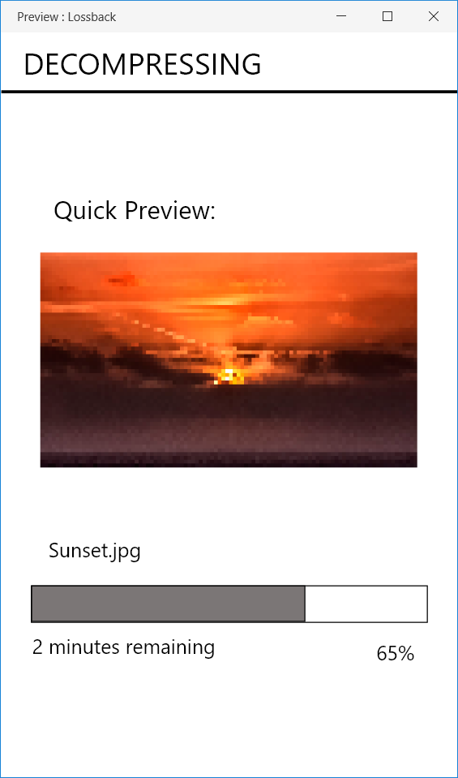

Figure 11.9 Compression in Desktop

Figure 11.8 Decompression in Mobile

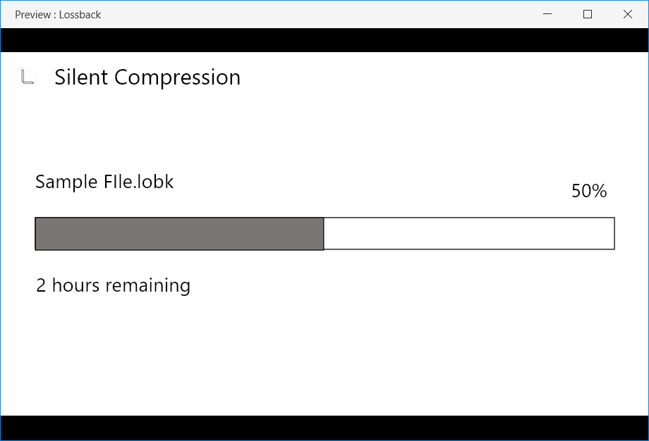

Figure 11.10 Silent Compression in Desktop

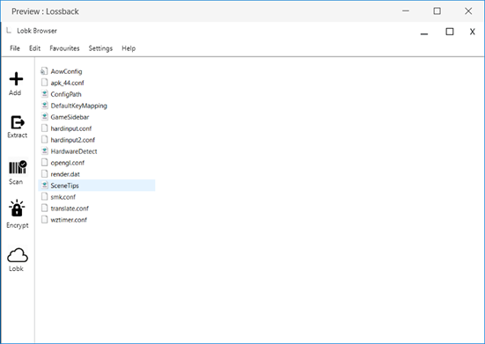

Figure 9.11 Lobk Browser

The Interface was entirely designed using Adobe XD and a prototype was also presented.

**11.4 FUNCTIONALITY TUNING**

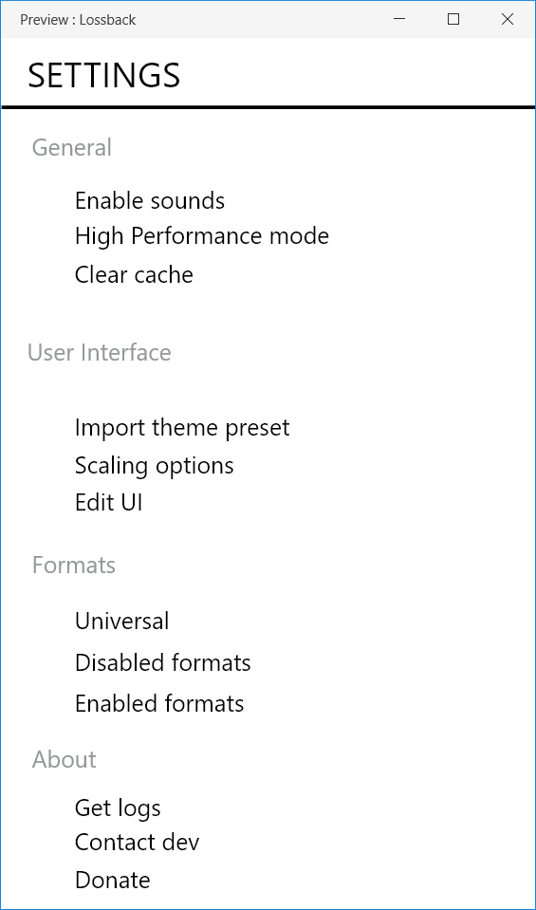Basic feature tuning such as General as well as advanced settings were included in this section. This included all the scaling and themeing options that were provided to LossBACK for mainitaing an ideal UI.

Figure 11.12 Mobile Settings

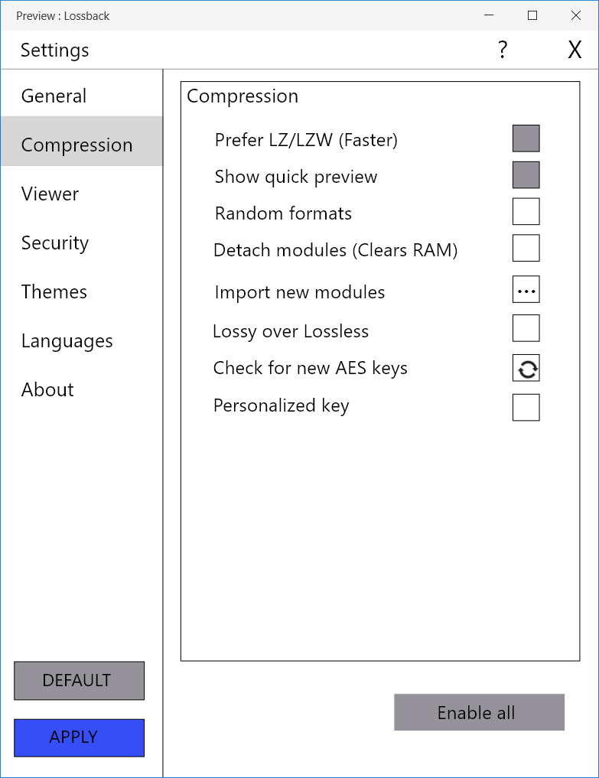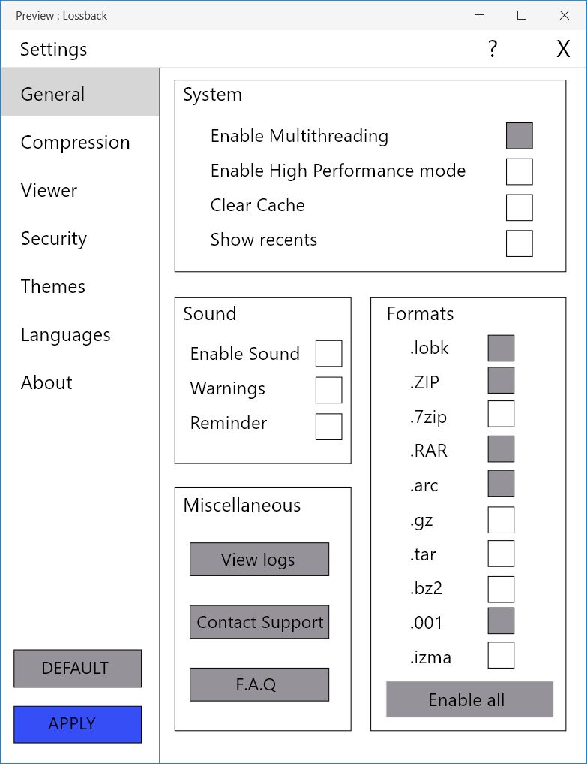

Figure 11.14 Compression Settings

Figure 11.13 General Settings

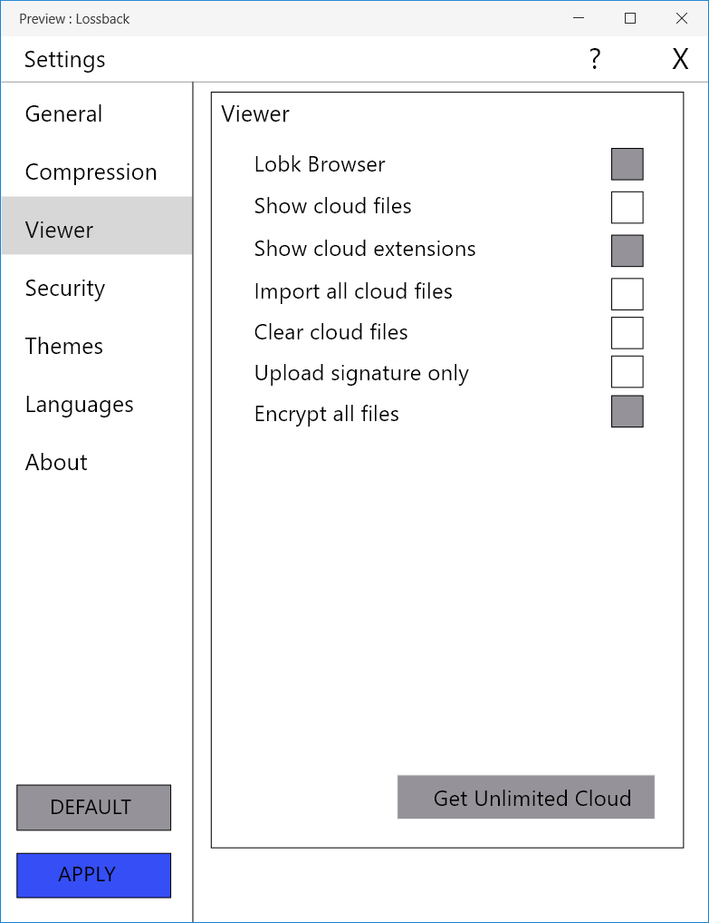

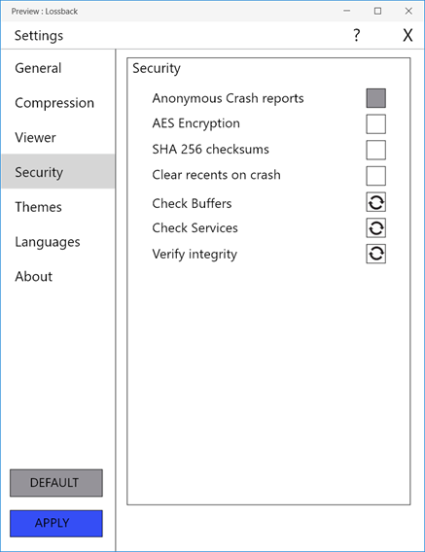

Figure 11.15 Viewer Settings

Figure 11.16 Security Settings

Figure 11.17 Theme Settings

Figure 11.18 Language Selection

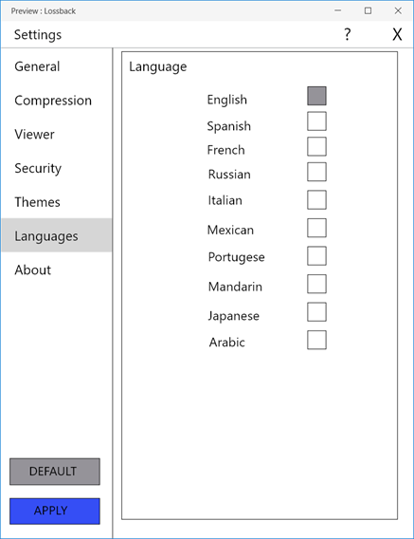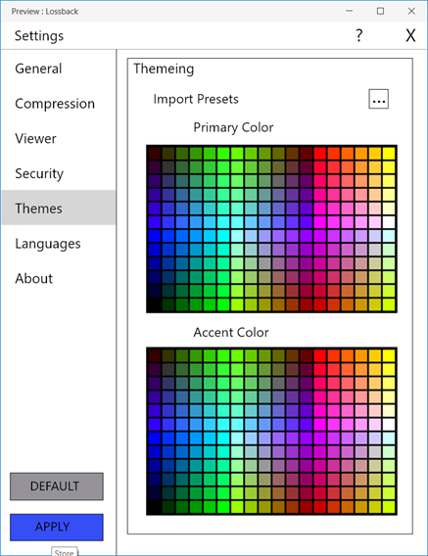

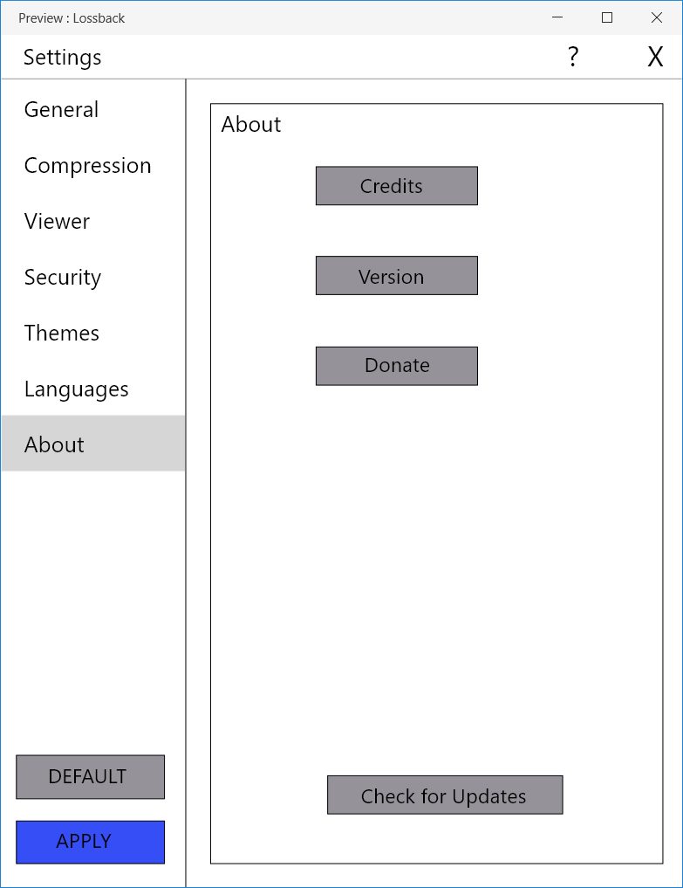

Figure 11.10 About page

The development was carried out using Adobe XD. A prototype was developed that even had minimum themeing abilities.

1. **CONCLUSIONS AND REFERENCES**

**12.1 CONCLUSIONS**

The idea of lossy compression replacing lossless compression when needed seemed like a break – through in the field of compression software. For this purpose, three leading compression software were chosen and their features, Interface, security measures, etc, compared extensively. This gave rise to the new compression software: LossBACK. The design of LossBACK, a modern compression software was completed successfully and its design presented. The design covered all major aspects of what was introduced in all stages of development. The final features of the software are the following:

* High Performance mode
* Silent softcompress
* Modular design
* LZ-LZW/DEFLATE swtich
* Greyscale
* Absolute themeing

**12.2 REFERENCES**

<https://en.wikipedia.org/wiki/WinZip>

[https://www.winzip.com/](https://www.winzip.com/win/en/landing/prodpagewz.html?gclid=Cj0KCQiAuf7fBRD7ARIsACqb8w5PlLck3YlhkZstrtJECNNhivHPHNYZDLrai2Jpqu58eRrqpMTH_XQaArIvEALw_wcB)

<https://www.win-rar.com/start.html?&L=0>

<https://en.wikipedia.org/wiki/WinRAR>

<https://www.7-zip.org/>

<https://en.wikipedia.org/wiki/7-Zip>

<https://www.online-tech-tips.com/software-reviews/7-zip-vs-winzip-vs-winrar/>

<https://www.maketecheasier.com/7-zip-vs-winrar-vs-winzip/>

<http://www.peazip.org/peazip-compression-benchmark.html>

<https://www.cvedetails.com/vulnerability-list/vendor_id-787/Winzip.html>

<https://www.cvedetails.com/vulnerability-list/vendor_id-1914/product_id-3768/Rarlab-Winrar.html>

<https://www.cvedetails.com/vulnerability-list/vendor_id-9220/7-zip.html>